SSG 817 CONTINUOUS ASSESSMENT

NAME: OLADIMEJI EMMANUEL ALADEROKUN

MATRIC NO: 219047012

COURSE: SSG817

MESM 2021/2022

1.

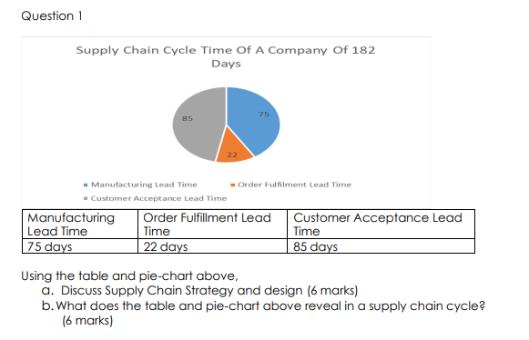

a. Discuss Supply Chain Strategy and design:

The information presented gives an overview of the lead times in different stages of the supply chain cycle, emphasizing the need for optimization in manufacturing lead time, quality control processes, customer communication, and supplier collaboration. The manufacturing lead time is the longest at 75 days, which could be due to several factors such as production capacity constraints or complex production processes. The order fulfillment lead time of 22 days is reasonable, indicating that the company has efficient processes in place. The long customer acceptance lead time of 85 days could be due to delays in product delivery or complex quality control processes.

The company could consider adopting lean manufacturing principles to eliminate waste, improve production processes, and increase efficiency. It could streamline quality control processes to reduce lead time and enhance customer satisfaction while maintaining quality. Building strong relationships with suppliers can help reduce lead times and ensure timely delivery of raw materials. The company could work closely with suppliers to optimize delivery schedules and ensure that raw materials are available when needed.

The manufacturing lead time of 75 days could indicate a make-to-order strategy, and the company could consider holding inventory of finished goods to reduce lead time if they follow a make-to-stock strategy. Overall, the data reveals potential areas for improvement in the supply chain cycle, and implementing these strategies could enhance supply chain performance and customer satisfaction.

b. What does the table and pie-chart above reveal in a supply chain cycle?

The table above provides information on the different lead times in the supply chain cycle, while the pie-chart can visually represent the percentage of time spent at each stage.

From the table and pie-chart, we can see that the manufacturing lead time is the longest, accounting for 53.6% of the total time taken in the supply chain cycle. The order fulfillment lead time accounts for 15.7% of the total time, while the customer acceptance lead time accounts for 30.7% of the total time.

Manufacturing: The long manufacturing lead time of 75 days is the most time-consuming stage, accounting for 53.6% of the total time taken in the supply chain cycle. This indicates that there may be opportunities to optimize production processes and reduce lead times.

Order fulfillment: The order fulfillment lead time of 22 days accounts for 15.7% of the total time taken in the supply chain cycle. This seems reasonable and indicates that the company has efficient processes in place for processing and delivering orders.

Customer acceptance: The customer acceptance lead time of 85 days accounts for 30.7% of the total time taken in the supply chain cycle. This is a relatively long lead time and indicates that the company may have opportunities to streamline quality control processes and improve communication with customers.

The table and pie chart provide information on the lead times of different stages in the supply chain cycle and highlight the need for optimization in manufacturing lead time, quality control processes, customer communication, and supplier collaboration. The manufacturing stage is the longest and needs improvement, followed by customer acceptance. The company could implement lean manufacturing, optimize production processes, and improve communication with customers to reduce lead times and enhance supply chain performance.

2.

Highlight different methods for systems modeling and forecasting and for choosing among different system alternatives with specific examples from telecommunications, manufacturing, environment/resources systems and transportation

Systems modeling and forecasting is a process of predicting how a system will behave in the future based on its past behavior and current trends. This process can be applied to a wide range of systems, including those in telecommunications, manufacturing, environment/resources, and transportation.

In telecommunications, systems modeling and forecasting can be used to predict the demand for mobile data services. For example, a company may use time-series analysis to identify patterns in past data usage and then use that information to forecast future demand. The company can then use this forecast to plan for capacity expansion and investment in new infrastructure.

In manufacturing, systems modeling and forecasting can be used to optimize production processes. For example, a company may use computer simulation to model different production scenarios and predict the impact of changes in production processes on output and efficiency. This information can then be used to make informed decisions about process improvements and capacity expansion.

In environment/resources systems, systems modeling and forecasting can be used to predict the impact of human activities on natural resources. For example, a government agency may use predictive modeling to forecast the impact of climate change on water resources and then use that information to develop policies for water conservation and management.

In transportation, systems modeling and forecasting can be used to optimize transportation networks and improve traffic flow. For example, a city may use traffic simulation to model different transportation scenarios and predict the impact of changes in traffic patterns on congestion and travel time. This information can then be used to make informed decisions about transportation infrastructure investments.

When choosing among different system alternatives, decision-making methods such as cost-benefit analysis, multi-criteria decision analysis, and decision trees can be used. For example, in telecommunications, a company may use cost-benefit analysis to evaluate the economic feasibility of different investment options for expanding its network infrastructure. In transportation, a city may use multi-criteria decision analysis to evaluate different options for reducing traffic congestion, considering factors such as cost, environmental impact, and social acceptability.

4.

a. Develop a casual loop diagram capturing important feedbacks, both positive and negative, to explain the preference and dominance of PHCN in the economy over Generating set in Lagos State. (6 marks)

Reinforcing Loops:

PHCN Satisfaction Loop: This loop shows how improvements in PHCN's service delivery lead to increased user satisfaction and a shift in preference from Gensets to PHCN. This shift reduces the demand for Gensets, which in turn reduces their usage, leading to a more stable power supply and further increases the preference for PHCN. This loop is driven by the increased reliability of PHCN, which leads to more users and industrial users, creating more jobs and increasing GDP.

Political Stability and Investment Loop: This loop shows how improvements in political stability in Lagos State lead to increased confidence in foreign and local investors to invest in the state. This increased investment leads to economic growth, which in turn leads to increased demand for electricity. As PHCN expands its capacity to meet this demand, it becomes more reliable, leading to increased user satisfaction and further economic growth. This loop reinforces the stability and growth of the Lagos State economy and the dominance of PHCN.

Infrastructure and Reliability Loop: This loop shows how improvements in infrastructure, such as transmission substations, lead to a more reliable power supply, which in turn leads to more investment in infrastructure and further improvement in reliability. This loop reinforces the reliability and expansion of the power grid, which further strengthens the dominance of PHCN.

Balancing Loops:

Environmental Pollution and Health Concerns Loop: This loop shows how the use of Gensets due to unreliable power supply from PHCN leads to increased noise and air pollution, which causes health concerns among the population. This pressure puts on the government to regulate and limit the use of Gensets, which increases the cost of operating and maintaining Gensets, making them less attractive to users and reducing their preference over PHCN.

Technological Advancements Loop: This loop shows how advancements in technology lead to more efficient and cost-effective renewable energy sources. This reduces the cost of generating electricity from renewable sources, making them more attractive to users and reducing the preference for Gensets. As more users switch to renewable sources, demand for electricity from PHCN increases, leading to increased reliability and further reducing the preference for Genset.

User Cost and Income Loop: This loop shows how the cost of electricity from PHCN and Gensets affects user preference. As the cost of electricity from PHCN increases, users may switch to Genset due to their lower operating costs. However, as more users switch to Genset, the increased demand for fuel and maintenance leads to higher costs, making them more expensive than PHCN. This increased cost reduces the income of users, leading to decreased demand for electricity and slower economic growth.

The Energy Losses and Investment Loop is a balancing feedback loop that shows the relationship between energy losses and investment in the electricity distribution system. This loop highlights the importance of balancing the need to reduce energy losses with the need for ongoing investment in the distribution system. If energy losses are reduced too quickly without sufficient investment, the system's reliability could suffer, leading to further energy losses and a cycle of decreased investment and increased energy losses. Conversely, if investment is prioritized over reducing energy losses, the system's inefficiencies will persist, resulting in continued energy waste and a lack of progress towards a more sustainable and reliable electricity distribution system.

b.

What are the likely impact of the outcome on the dynamics and strategies for success in the Power Sector market in the next five years in Lagos State. (6 marks)

The likely impact of the outcome depicted in the causal loop diagram on the dynamics and strategies for success in the Power Sector market in Lagos State in the next five years could be as follows:

Increase in Investment and Expansion of PHCN: With an increase in political stability, there would likely be more investment and expansion of the PHCN. This could result in an increase in its customer base, leading to further economic growth and increased job opportunities. To compete effectively, other players in the market would have to develop strategies to expand their capacity and improve their service delivery.

Decrease in Genset Usage: As the reliability of PHCN improves and more users switch to it, there would likely be a decrease in the use of Gensets. This could result in a reduction in air and noise pollution, which could improve the overall health and wellbeing of the population. Other players in the market would need to adapt their business models to accommodate the changing dynamics, perhaps by exploring renewable energy sources.

Regulatory Changes: As concerns about environmental pollution and health increase, there could be more pressure on the government to regulate and limit the use of Gensets. This could lead to an increase in the cost of operating and maintaining Gensets, making them less attractive to users. Other players in the market would have to develop strategies to mitigate the impact of the regulation on their business.

Technological Advancements: With advancements in technology, there would likely be more efficient and cost-effective renewable energy sources available. This could result in a reduction in the cost of generating electricity from renewable sources, making them more attractive to users, and reducing the preference for Gensets. Other players in the market would need to adopt and invest in the new technologies to remain competitive.

In summary, the likely impact of the outcome depicted in the causal loop diagram on the dynamics and strategies for success in the Power Sector market in Lagos State in the next five years could lead to increased investment and expansion of PHCN, decreased use of Gensets, regulatory changes, and the adoption of new technologies. Players in the market would have to adapt their business models and develop strategies to remain competitive in the changing market dynamics.

5.

As customer changes cause a project to fall behind, the management can accelerate the schedule, use overtime and hire more people, forming negative feedbacks designed to get the project back on track (solid lines). However, each of these negative loops triggers side effects that undercut the intended effects, forming vicious cycles (positive feedbacks, shown by the dashed lines). Draw inference from diagram above, kindly discuss each of the side effects triggered by each of the negative loops. (12 marks)

The diagram shows a system of negative and positive feedback loops that affect the completion of tasks in a project. The negative feedback loops are intended to help the project get back on track, while the positive feedback loops have unintended side effects that undercut the progress of the project.

One of the negative feedback loops shown in the diagram is the use of overtime. The intended effect of overtime is to increase the effective number of people working on the project and speed up progress. However, excessive or extended overtime can lead to fatigue and burnout, reducing productivity and quality and increasing the stock of undiscovered rework. Burnout can also lead to absenteeism and attrition, reducing the number of people on the project. These unintended effects form positive feedbacks that act as vicious cycles to undercut the progress-enhancing effect of overtime.

Another negative feedback loop shown in the diagram is the hiring of more people. The intended effect is to increase the number of people working on the project and speed up progress. However, rapid hiring can dilute the experience base of the employees and erode recruiting standards, lowering productivity and quality and slowing progress.

Management may also try to force employees to work harder and overlap activities, which can increase productivity but also lead to unintended side effects such as work out of sequence and coordination problems as important information is missed. This can lead to morale problems, cutting productivity and quality and increasing absenteeism and attrition.

The rework cycle also has unintended side effects. Lower quality means more tasks contain errors. Because many of these errors are not discovered immediately, subsequent work begins using designs, materials, and information that appear to be correct at the time but are later recalled for rework. This makes the process even more costly, and small changes in customer specifications can snowball into much larger delay and disruption despite management’s best efforts to get the project back on track.

In conclusion, negative feedback loops are intended to help a project get back on track, but they can have unintended side effects that form positive feedbacks and undercut progress. It is important for management to recognize these unintended consequences and to take action to mitigate them to keep the project on track.

3.

Question 3 a. Plot a simulation diagram of how MTN or Glo or Airtel or 9Mobile telecommunication system works in Nigeria (4 marks) b. Draw a simulation diagram of money transfer of $USD5,000 between Zenith Bank, Lagos and Citi Bank, New York. (4 marks) c. Using the 5 steps of modelling process design an AI to solve traffic congestion at a particular busy junction in Akoka Yaba, Lagos. (4 marks)

a.

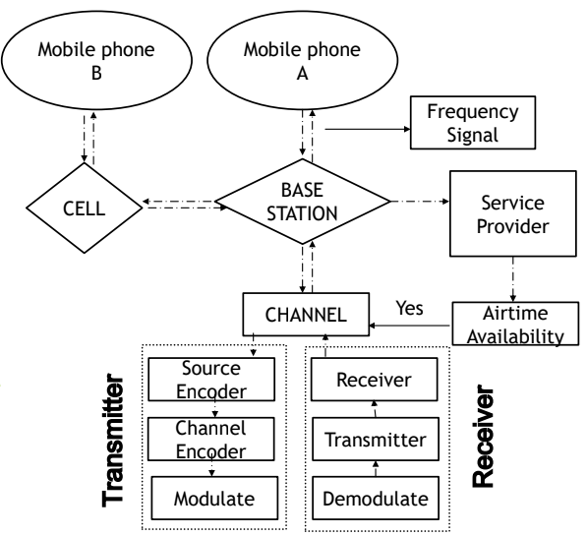

b.

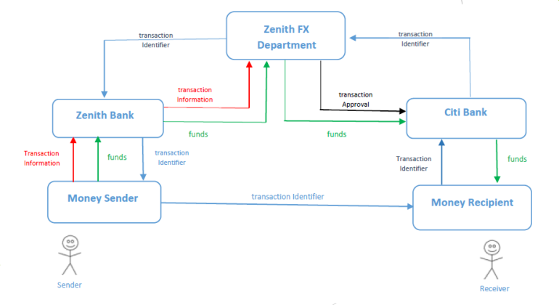

c.

Step 1: Problem Identification and Definition

The problem is traffic congestion at a busy junction in Akoka Yaba, Lagos, which is causing delays and frustration among drivers and commuters. The objective is to develop and implement an AI algorithm that can predict and mitigate traffic congestion at the junction based on the analyzed data.

Step 2: Data Collection and Preparation

Data related to traffic volume, vehicle types, road conditions, weather, and other relevant factors that affect traffic flow at the junction should be collected. The data can be collected using sensors, cameras, and other monitoring devices. The data should be cleaned and preprocessed to remove any errors and inconsistencies.

Step 3: Model Development

A predictive model using machine learning algorithms such as regression, decision trees, or neural networks should be developed. The model should use the collected data to predict traffic volume and flow at the junction. The model should also identify the factors that contribute to traffic congestion and recommend mitigation strategies.

Step 4: Model Implementation and Testing

The model should be implemented using software tools such as Python or R. The model should be tested using historical data to evaluate its accuracy and effectiveness in predicting traffic flow and mitigating congestion. Additionally, the model should be tested in real-time to evaluate its performance under different traffic scenarios.

Step 5: Model Deployment and Monitoring

Once the model is tested and validated, it should be deployed in real-time to monitor and predict traffic flow at the junction. The AI algorithm should provide real-time recommendations to drivers and traffic controllers to mitigate congestion and improve traffic flow. The model should be monitored regularly to update its parameters and ensure its continued effectiveness. Additionally, the system should collect feedback from traffic controllers and drivers to continually improve its performance.

SECTION B

3. C

4. B

5. B

6. A

7. A

8. C

9. C

10. C

11. C

12. D